Smart Home Automation System

Table of Contents

1 Introduction 5

2 Objective 5

3 Scope of Work 6

4 Key Features 6

5 System Specifications 7

6 System Overview 7

6.1 System Architecture 7

6.2 Flow Chart 8

6.3 Major Components 9

6.4 I/O Interface 9

7 Software 10

7.1 System Requirements 10

Software Requirements 10

Web Dashboard 10

Mobile Dashboard 10

7.2 Project Image 11

7.3 Software Code 11

8 Conclusion 33

List of Tables

Table 1 Key Features 5

Table 2 System Specifications 6

Table 3 Component List 8

Table 4 System I/O Interface 8

# Introduction

The Smart Home Automation System is designed to offer a modern, efficient, and user-friendly solution for managing essential household functions. By integrating various sensors and control mechanisms, the system ensures enhanced monitoring, safety, and convenience. At the core of the system is the STM32F401RET microcontroller, which coordinates all sensor inputs and control outputs. The setup includes real-time environmental monitoring, flexible control options (both wireless and manual), appliance automation, and intelligent fan speed regulation—creating a centralized platform for smarter living.

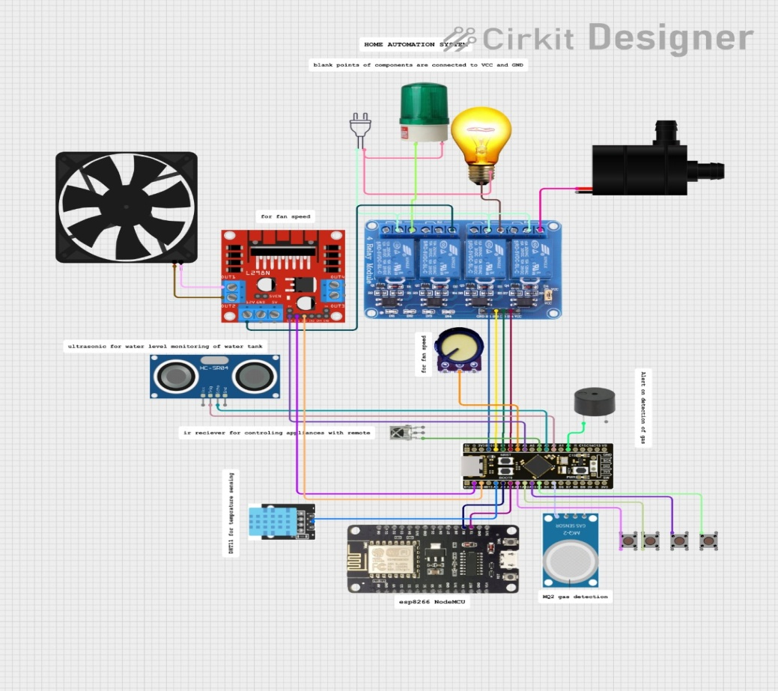

Figure 1 System Circuit Diagram

# 

# Objective

The primary objective of this project is to develop an integrated smart home system that improves the quality of life through automation and environmental awareness. The goals include:

* **To monitor key environmental parameters** such as water level, temperature, and humidity using ultrasonic and DHT11 sensors.
* **To provide seamless control** of home functions through Wi-Fi (ESP8266) for remote access and physical buttons for local interaction.
* **To automate household appliances** using relay modules, enabling users to manage up to four devices easily.
* **To regulate ventilation** efficiently by controlling fan speed through PWM based on environmental data or user input.

# Scope of Work

The Smart Home Automation System project is divided into three main tasks, covering circuit design, software development, and hardware implementation. Each phase contributes to the successful integration of sensing, control, and automation features.

* **Task 1: Circuit Design & Simulation**  
  The initial phase involved designing and simulating the complete circuit using **Cirkit Designer**. This allowed for accurate placement of components such as sensors, microcontroller, relays, and communication modules, ensuring proper connections and circuit functionality before hardware implementation.
* **Task 2: Embedded Software Development**  
  The second task focused on programming the system using **STM32CubeIDE**. The STM32F401RET microcontroller was configured to interface with the DHT11 sensor, ultrasonic module, ESP8266 Wi-Fi module, and relay modules. This stage involved coding sensor readings, control logic, and communication protocols for both manual and wireless control.
* **Task 3: Hardware Implementation**  
  In the final task, the verified circuit was soldered onto a **veroboard**. This involved assembling all components, ensuring secure connections, and integrating the system into a functional prototype. Testing was conducted to validate real-time performance and reliability.

# Key Features

Table 1 Key Features

|  |  |
| --- | --- |
| **Feature** | **Description** |
| Environmental Monitoring | Measures **temperature**, **humidity** (DHT11), and **water level** (ultrasonic sensor) in real-time. |
| Dual Control Modes | Supports both **manual control** using push buttons and **remote control** via **Wi-Fi (ESP8266)**. |
| Appliance Automation | Controls up to **4 household appliances** (e.g., fan, bulb, LED, pump) using **relay modules**. |
| Fan Speed Regulation | Uses **ADC and PWM** to automatically or manually adjust fan speed based on sensor data. |

# System Specifications

Table 2 System Specifications

|  |  |
| --- | --- |
| **Specification** | **Description** |
| Microcontroller Unit | STM32F401RET Cortex-M4 microcontroller (programmed using STM32CubeIDE). |
| Sensors | Ultrasonic sensor for water level, DHT11 for temperature and humidity. |
| Communication Module | ESP8266 Wi-Fi module for wireless data transmission and control. |
| Actuators | 4-channel relay module to switch electrical appliances; fan controlled via PWM. |

# System Overview

The Smart Home Automation System is designed to monitor and control household appliances using sensor data and dual-mode control. It uses an **STM32F401RET microcontroller** to read data from environmental sensors and control devices through relays and PWM. Users can operate the system manually via buttons or remotely using **Wi-Fi (ESP8266)**. The system ensures efficient appliance management and real-time monitoring of temperature, humidity, and water level.

## System Architecture

The system is built around a modular structure:

* **Sensors:** Ultrasonic sensor for water level, and DHT11 for temperature and humidity.
* **Controller:** STM32F401RET processes data and controls outputs.
* **Control Inputs:** Physical buttons for manual switching.
* **Wireless Interface:** ESP8266 module for remote operation over Wi-Fi.
* **Actuators:** Relay module controls four appliances; PWM regulates fan speed.
* 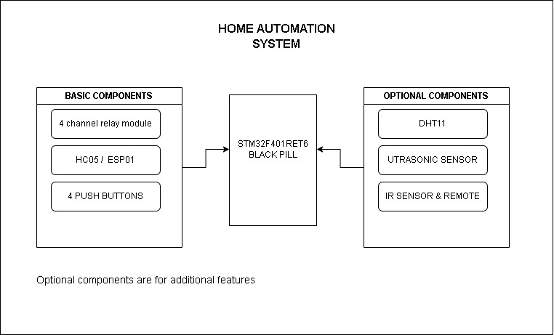**Communication:** UART sends feedback to monitor system status.

Figure 2 System Block Diagram

## Flow Chart

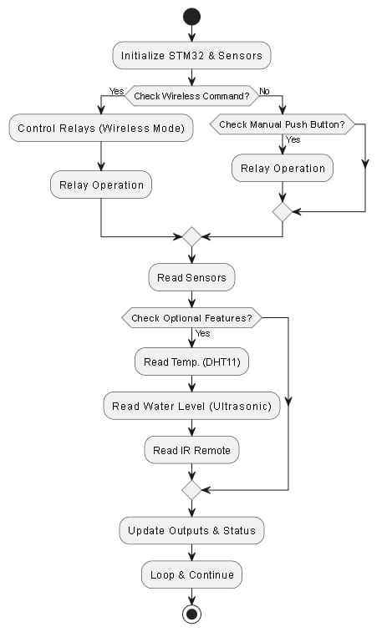

Figure 3 Flow Chart

## Major Components

The system comprises of following components:

Table 3 Component List

|  |  |  |  |
| --- | --- | --- | --- |
| **Sr. #** | **Item** | **Note** | **Part #/ Web-link** |
| 1 | STM32f401ret6 | microcontroller | [stm](https://www.st.com/resource/en/datasheet/stm32f401re.pdf) |
| 2 | Esp8266 node MCU | Wi-Fi module | [esp8266](https://www.theengineeringprojects.com/2018/08/esp8266-pinout-datasheet-features-applications.html) |
| 3 | DHT11 | Temperature sensor | [DHT11](https://www.mouser.com/datasheet/2/758/DHT11-Technical-Data-Sheet-Translated-Version-1143054.pdf?srsltid=AfmBOorkSq_RQFio3vI4-Nl3P3MCsBT4xTctEvGL9vBgVoudBAFjRpir) |
| 4 | HCSR04 | Ultrasonic Sensor | [ultrasonic sensor](https://www.arduinofacile.it/wp-content/uploads/2021/05/HC-SR04-ETC.pdf) |
| 5 | KY-022 | IR receiver | [IR reciever](https://www.alldatasheet.com/datasheet-pdf/pdf/2045023/AGELECTRONICA/KY-022.html) |
| 6 | Potentiometer | PWM control | [PWM](https://www.alldatasheet.com/category/index.jsp?sSearchword=Pwm&gad_source=1&gad_campaignid=747689886&gbraid=0AAAAADcdDU-r3MCaCkTvb0Pe7Hq1AS4Je&gclid=Cj0KCQjw64jDBhDXARIsABkk8J4DweTqni5QMm89_NcToRlbM5SVTBCW9DBfOoMvPhYwSC8OMSVB41EaAlwLEALw_wcB) |
| 7 | L298N | Motor Driver | [motor driver](https://www.alldatasheet.com/view.jsp?Searchword=L298n%20datasheet&gad_source=1&gad_campaignid=149541607&gbraid=0AAAAADcdDU_VZjWs24QvJDanl3seJvmIY&gclid=Cj0KCQjw64jDBhDXARIsABkk8J7trbY-HmkDoLciz8czHdY0a9olCICQ4puZy6-A43mpO0KH2LTgGxkaArT1EALw_wcB) |
| 8 | Relays | 4 channel mechanical relay | [relay](https://components101.com/switches/5v-four-channel-relay-module-pinout-features-applications-working-datasheet) |
| 9 | Push Buttons | 4x for manual control | [push button](http://alldatasheet.com/category/index.jsp?sSearchword=Button%204-pin%20push&gad_source=1&gad_campaignid=747689886&gbraid=0AAAAADcdDU-r3MCaCkTvb0Pe7Hq1AS4Je&gclid=Cj0KCQjw64jDBhDXARIsABkk8J6v2vaH6gWrf_A619e8tJKEBWpi7q2gjyT7WUIITG48iD_giNbQaDUaAtfdEALw_wcB) |

## I/O Interface

Table 4 System I/O Interface

|  |  |  |  |
| --- | --- | --- | --- |
| **System Name** | | | |
| **Connector** | **PIN** | **SIGNAL** | **DESCRIPTION** |
| J1 | 1 | PA2 (TRIG) | Ultrasonic sensor trigger pin |
| 2 | PA3 (ECHO) | Ultrasonic sensor echo pin |
| 3 | PA4 | IR receiver |
| 4 | PB0 | Relay 1 control (Appliance 1) |
| 5 | PB1 | Relay 2 control (Appliance 2) |
| 6 | PB2 | Relay 3 control (Pump) |
| 7 | PB10 | Relay 4 control (Fan) |
| 8 | PA6 | PWM output (Fan speed control) |
| 9 | PA7 | ADC |
| J2 | 1 | PB13 | Polarity 1 |
| 2 | PB14 | Polarity 2 |
| 3 | PA8 | DHT11 data pin |
| 4 | PA11 | Button input for Relay 1 |
| 5 | PA12 | Button input for Relay 2 |
| 6 | PA15 | Button input for Relay 3 |
| 7 | PB3 | Button input for Relay 4 |
| 8 | PA9 | RX for ESP |
| 9 | PA10 | TX for ESP |

# Software

## System Requirements

### Software Requirements

We used **STM32CubeIDE** to program the **STM32F401RET** microcontroller, configure peripherals, and handle debugging. For the **ESP8266 Wi-Fi module**, the **Arduino IDE** was used to upload code and enable wireless communication with the STM32 via UART.

### Web Dashboard

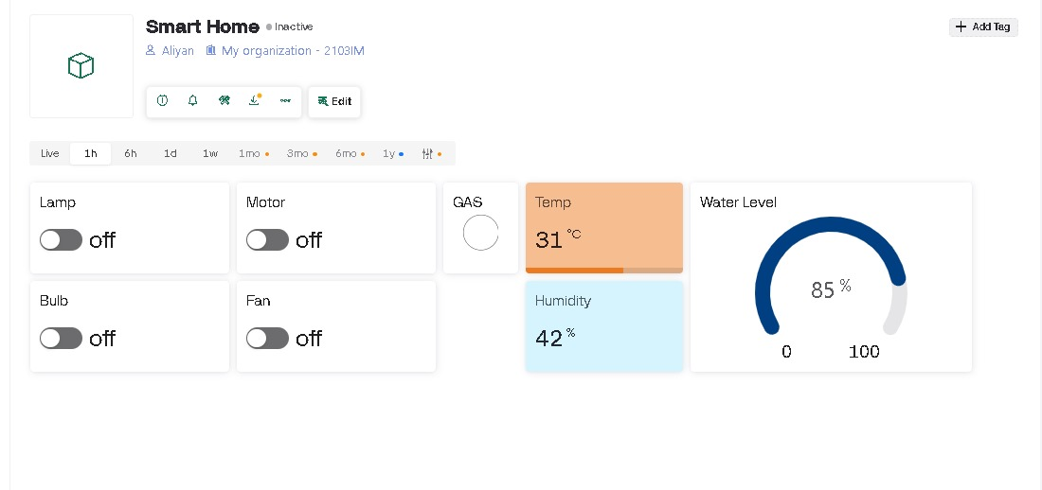

### Mobile Dashboard

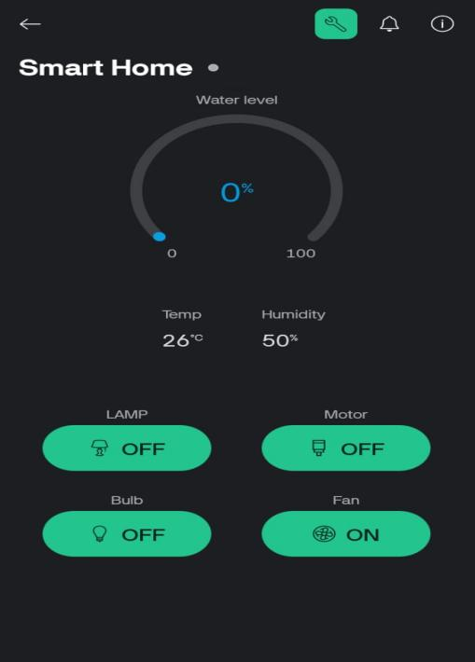

## Project Image

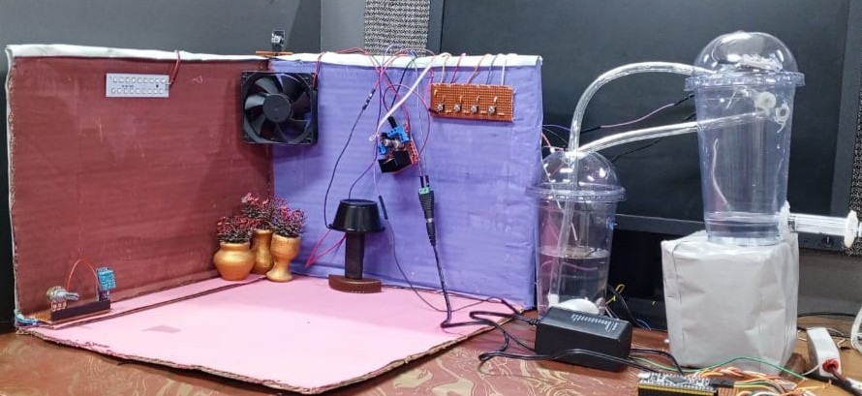

Figure 4 Project Image

## Software Code

Stm-code

Esp-code

# Conclusion

This Smart Home Automation System efficiently monitors temperature, humidity, and water level using DHT11 and an ultrasonic sensor, and controls up to four appliances through relays. It supports both manual buttons and remote control via the ESP8266 Wi-Fi module. Fan speed is adjusted using PWM based on ADC input. Developed using STM32CubeIDE and Arduino IDE, the system offers a reliable and practical solution for smart home management